|  |  |
| --- | --- |
| **Ex No: 01** | **CREATION OF WEBPAGE TO EMBED A IMAGE AND FIX**  **HOTSPOTS** |
| **Date: 28.08.2021** |

**AIM**

To Create a web page with the following using HTML

1. To embed an image map in a web page
2. To fix the hot spots

iii) Show all the related information when the hot spots are clicked.

**ALGORITHM**

1.To embed an image using Image Tag <Img>

2.<area shape=”” coords="” href="" alt="" />

3.To create a map with different attributes

a.<map name="planetmap">

b.</map>

4.To Fix hot spot with different styles

a.Circle

<area shape="circle" coords="0,0,82,126" href="sun.htm" alt="Sun"

b.Rectangle

<area shape="rect" coords="0,0,82,126" href="sun.htm" alt="Sun"

c.Poly

<area shape="poly" coords="0,0,82,126" href="sun.htm" alt="Sun"

5.Create a web pages related to the hotspot

6.Open a browser and display a web page

**CONCEPTS INVOLVED**

**What is Image Mapping**

In image mapping an image is specified with certain set of coordinates inside the image which act as hyperlink areas to different destinations. It is different from an image link since in image linking, an image can be used to serve a single link or destination whereas in a mapped image, different coordinates of the image can serve different links or destinations.

**Elements used in Mapping a Image**

There are three basic html elements which are required for creating a mapped image.

1. **Map :**It is used to create a map of the image with clickable areas.
2. **Image :**It is used for the image source on which mapping is done.
3. **Area :**It is used within the map for defining clickable areas.

**PROGRAM**

**Index.html**

<!DOCTYPE html>

<html>

<body>

<h1>The map and area elements</h1>

<p>Click on the Hotspots to go to a new page and read more about the Places:</p>

<img src="https://www.mapsofindia.com/images2/india-map-2019.jpg" alt="Workplace" usemap="#workmap" width="209" height="242">

<map name="workmap">

<area shape="rect" coords="83,41,57,63" alt="delhi" href="Delhi.html">

<area shape="rect"coords="149,129,124,83" alt="calcutta" href="Kolkata.html">

<area shape="rect" coords="89,184,56,226" alt="tamilnadu" href="Chennai.html">

</map>

<p>N.G. Santhosh Sudhaan<br/>913119205038</p>

</body>

</html>

**Chennai.html**

<html>

<body bgcolor="mistyrose">

<font face="Times New Roman" size="10" color="blue">

<center>Chennai is the capital of Tamil Nadu<br> and <br>It is famous for "Marina beach"<br> which is second largest beach in asia<br>

<a href="index.html">Home Page</a></center>

</font>

</body>

</html>

**Kolkata.html**

<html>

<body bgcolor="cyan">

<font face="Consolas" size="12" color="RED">

<center><b><i>Kolkata is one of the busiest city in INDIA<br> and <br>It is Famous for

"Victoria Palace"</i></b><br/>

<a href="index.html">Home Page</a></center>

</font>

</body>

</html>

**Delhi.html**

<html>

<body bgcolor="SKYBLUE">

<font face="Arial" size="10" color="RED">

<center><b><i><tt>Delhi is the capital of our INDIA<br> and <br>More IT companies are

Camped at Delhi</tt></i></b></center>

<a href="index.html">Home Page</a>

</font>

</body>

</html>

**OUTPUT**

**index.html**

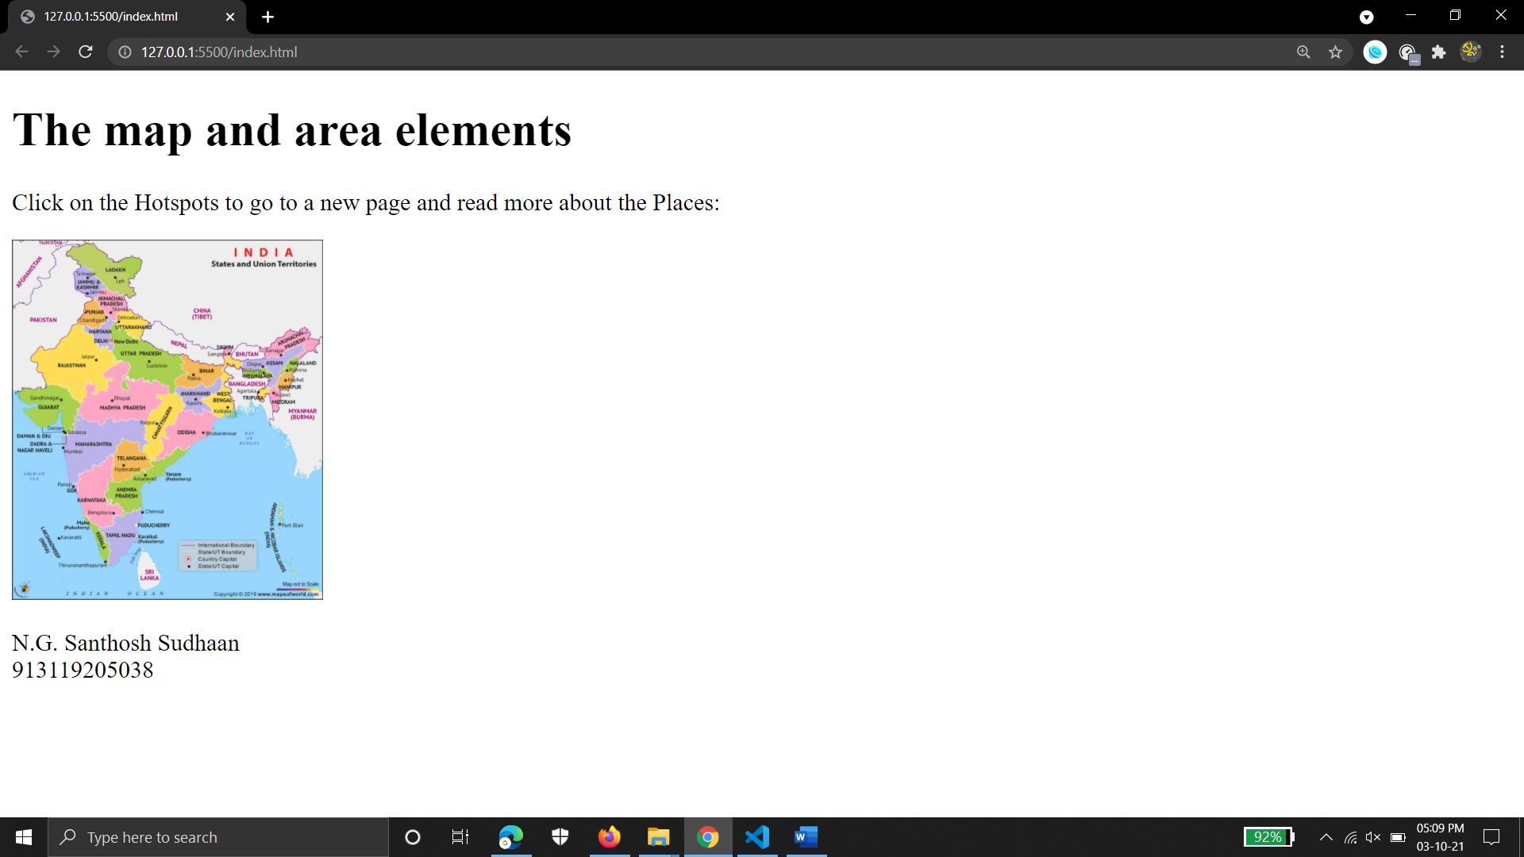

**Chennai.html**

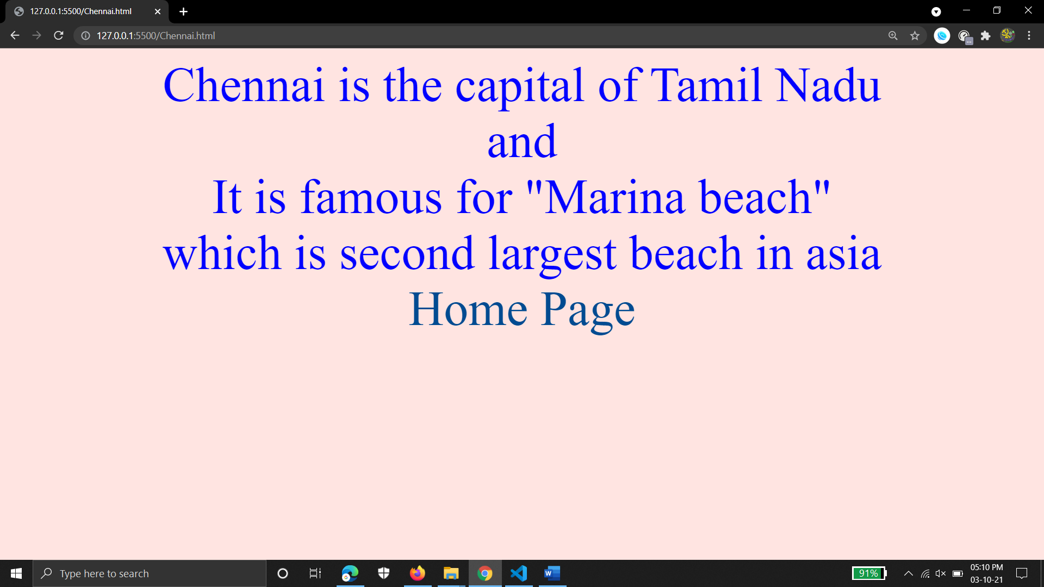

**kolkata.html**

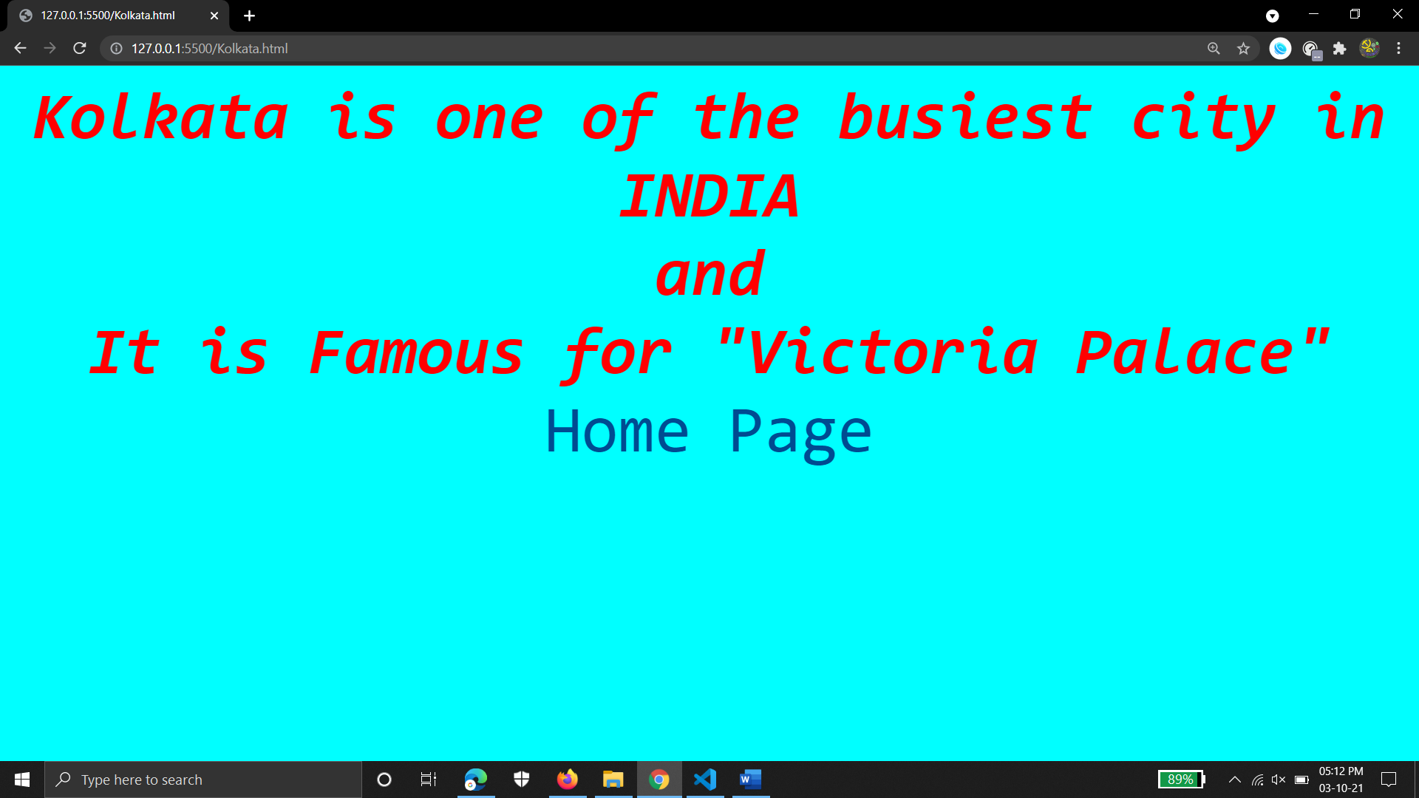

**delhi.html**

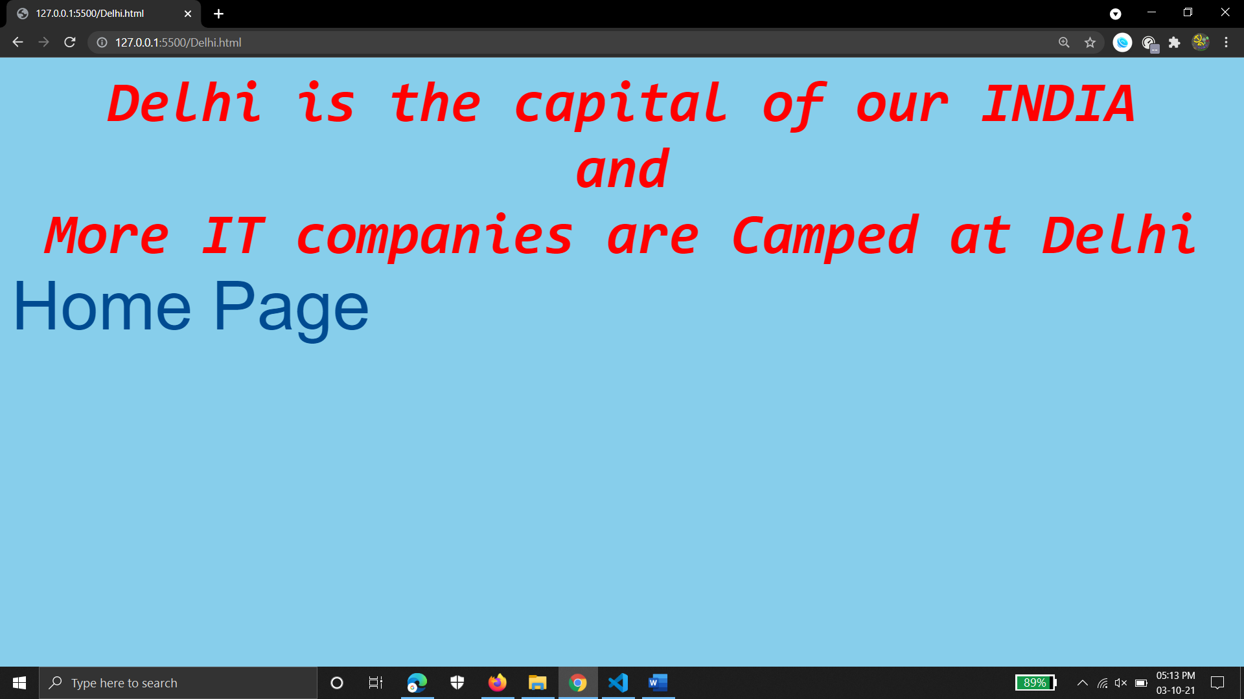

**RESULT**

In this experiment, the webpage using image maps was created and hotspots were fixed.